**Press release**

For immediate release

**Video clips to present the realities of agriculture in the Montérégie**

**“OUR COUNTRYSIDE: A LIVING SPACE TO SHARE”**

**Montérégie, April 19, 2021** – Awareness-raising activities are continuing in the Montérégie as part of the “Our countryside: a living space to share” project. Four new animated video clips are now available to encourage living together in agricultural areas. The fun and informative clips address the main themes related to agricultural activities: odours and noise, sharing the roads, soil health, water, and pesticide-use.

The agricultural environment offers many advantages, including the beauty of the landscape and access to fresh products. However, at certain times of year, residents must show patience in dealing with the challenges of agriculture. Here is a link to watch the video clips, which illustrate the vitality of the agricultural zone in the Montérégie.

[**https://www.youtube.com/playlist?list=PLqyyXSL3FbFoLO62vftT-cV9x1BGlDjzx**](https://www.youtube.com/playlist?list=PLqyyXSL3FbFoLO62vftT-cV9x1BGlDjzx)

**Various communication tools to reach the public**

The new video clips have now completed the toolkit developed to encourage living together and dialogue between the Montérégie’s population and its farmers. Several visuals and informational messages have been disseminated across multiple platforms for the partners in the awareness-raising campaign, “Our Countryside: A living space to share.” Newsletters, municipal bulletins, and social media publications have reached and raised awareness among the general public throughout the past year. A brochure will also be distributed in the municipalities. In addition, the very popular activity, *Agriculture, my neighbour!* will be relaunched in some municipal day camps this summer.

**The project partners**

The project partners include: the RCMs of Acton, Beauharnois-Salaberry, Brome-Missisquoi, Haut-Richelieu, Haut-St-Laurent, Jardins-de-Napierville, Haute-Yamaska, Marguerite-D’Youville, Maskoutains, Pierre-De Saurel, Roussillon, Rouville, and Vallée-du-Richelieu, Greater Longueuil, the Montérégie UPA Federation (MUPAF), and the Montérégie regional office of the Ministry of Agriculture, Fisheries, and Food (MAPAQ). These organizations are pooling resources and efforts to develop strategies and tools to ensure this campaign to raise awareness has a regional reach. The campaign to raise awareness about living together in harmony in the Montérégie’s agricultural zone was funded by the MAPAQ’s Territories program: Bio-food priorities, as well as by the UPA, the partner RCMs and Greater Longueuil, and will continue through October 2021.

- 30 -

Sources:

Living Together Project:

Caroline Deschamps, Montérégie UPA Federation (MUPAF)

450 774-9154, extension 5227 [cdeschamps@upa.qc.ca](mailto:cdeschamps@upa.qc.ca)

Promotional materials for the campaign:

Brigitte Marcotte, Expansion PME

450 446-2880, extension 2703 [bmarcotte@expansionpme.org](mailto:bmarcotte@expansionpme.org)

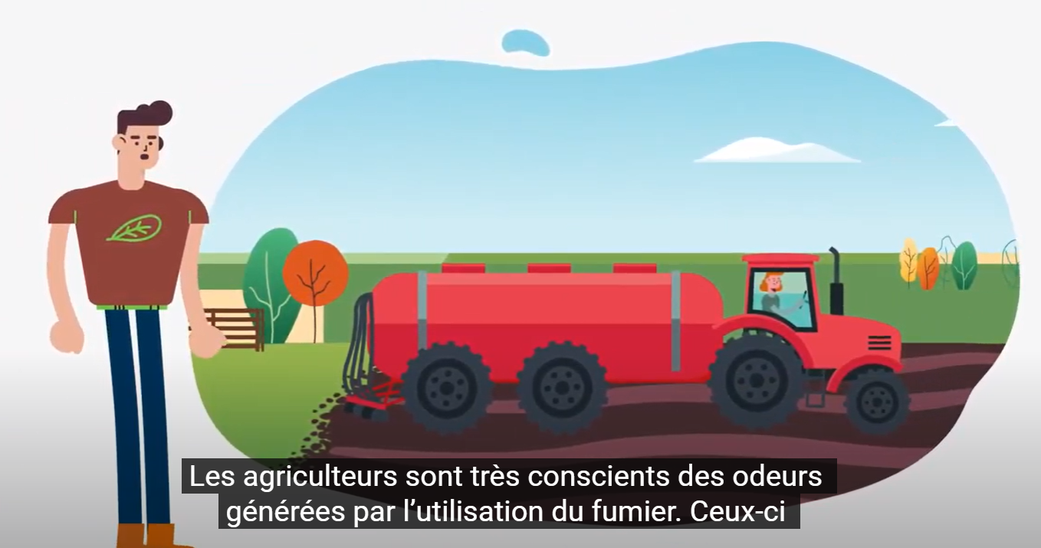

Visual from the video clip on the theme of odours and noise

Brochure for living together in harmony in the Montérégie’s agricultural zone